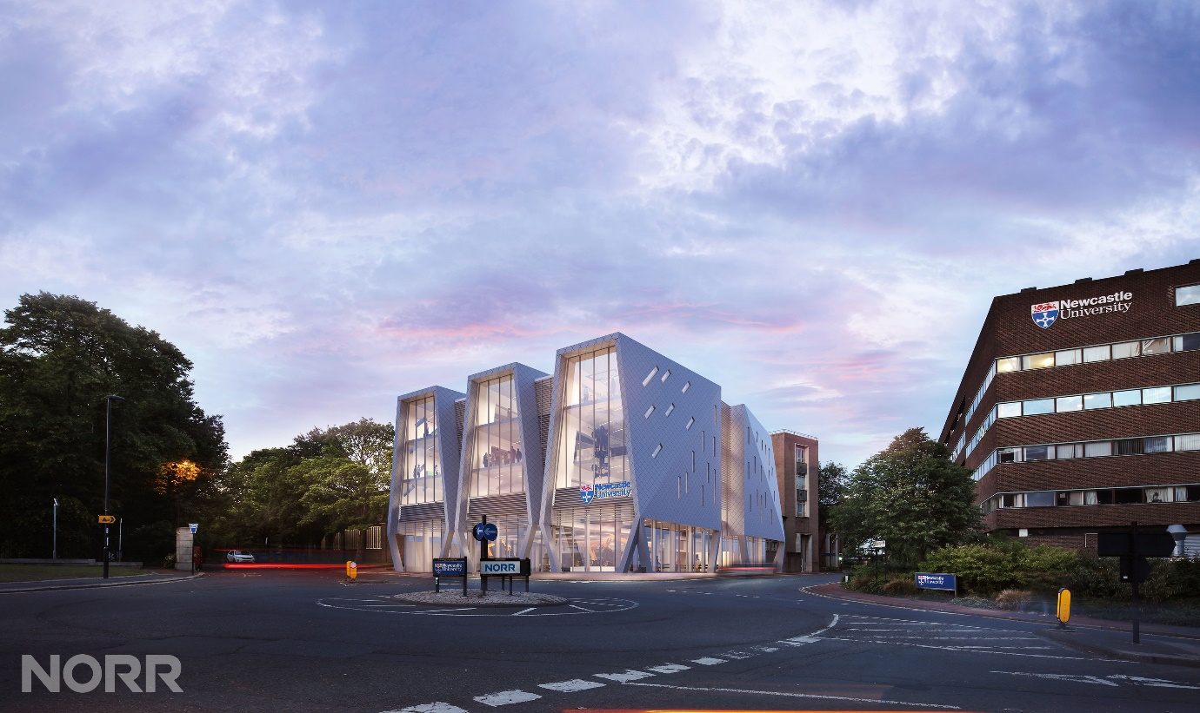

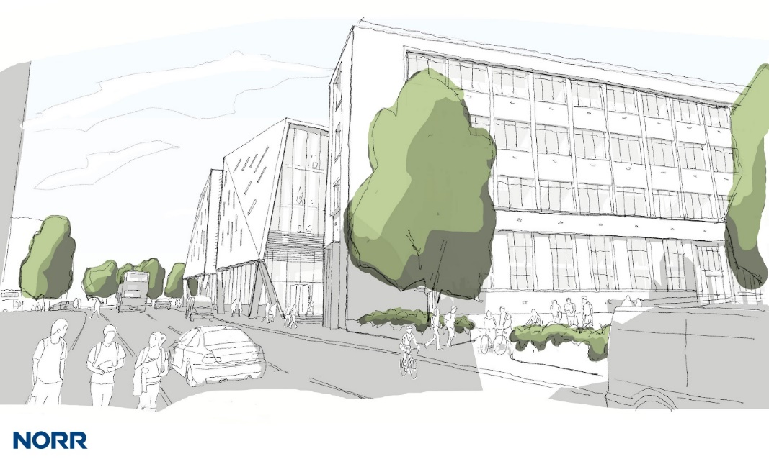

**The Stephenson Building redevelopment.**

The project is currently in the detailed briefing stage for the School of Engineering.

Images provided are impressions of what could be achieved on the important gateway site for the University.

